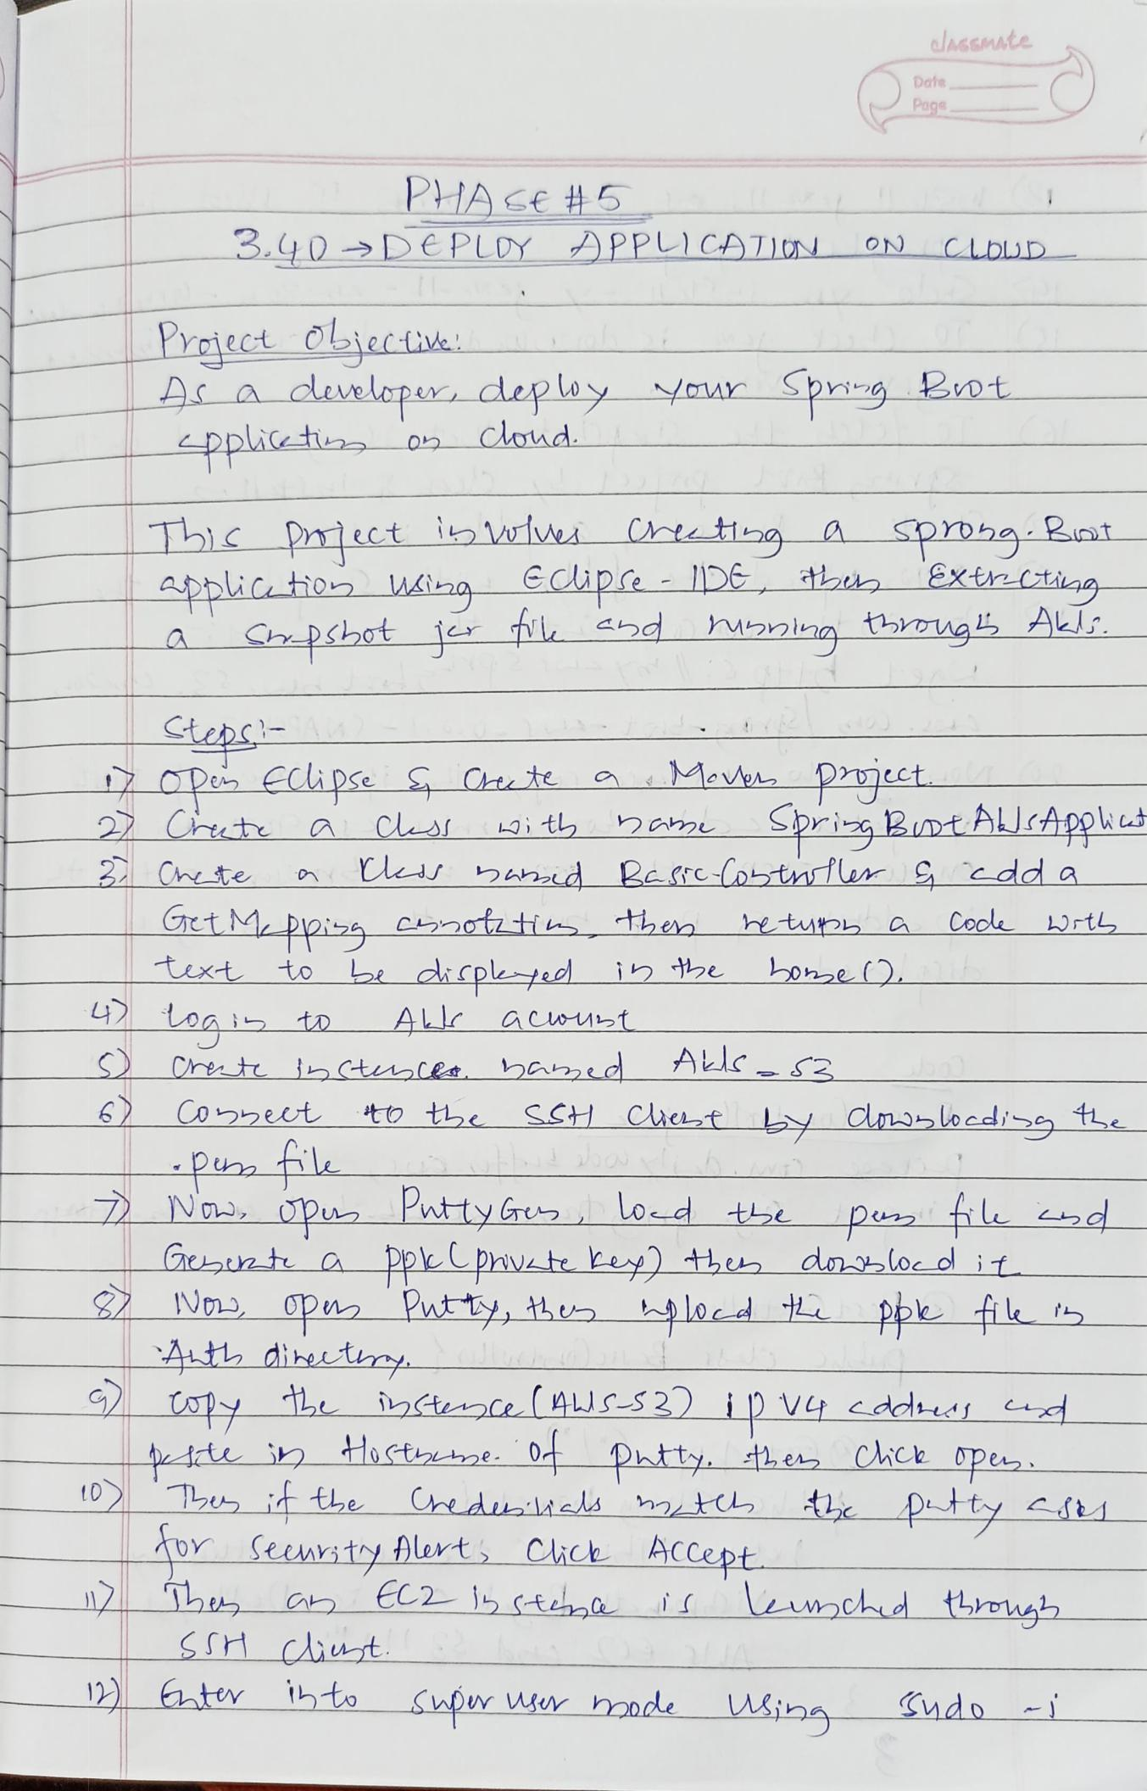
alhssmate

Date
Poge

PHASe H5
3.40 DEPLDY PPL)CATIU ON CLDLD

Proiect Oliecii
A adlevelapr dep Wy cu Spi iot
ppuci 03 Cloud

Th Pmect iblei Spoha Pint
pplicio MAnq Edupce -IDE t xtrtilaa-
- Chphot_jflhd Maning ^{hugALJ}

Ctepc=
OPe Cipse Cte a Meve Pmct
2 Cute a Cls t 9uSprig Bunt ALlcApoku

Chtete a Ces bnd Rere(pbt r g cdda

TtMpoi C2atzti then tup a Cocl rt

ext to b dicplepeo in e hone(O

Loaistn A _aCwUEt

Cret bctule hG2ed
- ^{Co5eut tt tbe} SCH Caet Ly Cnbediso tL

No 0p PwttyCrus Lod te p hle nd
acetnta pkphvete Le th_dosloe dit
32Non pu Pwtty th lod ppki ts ALt dietry

tay e ictsce. ASS2) i p Vy cddd dH

Dty cAU_
- emstty Alerts_Chch ACCept

SSH_CAiut
¹ ^{te} ^{ht} SwpwMUy hmode _{Wing} Cudo -
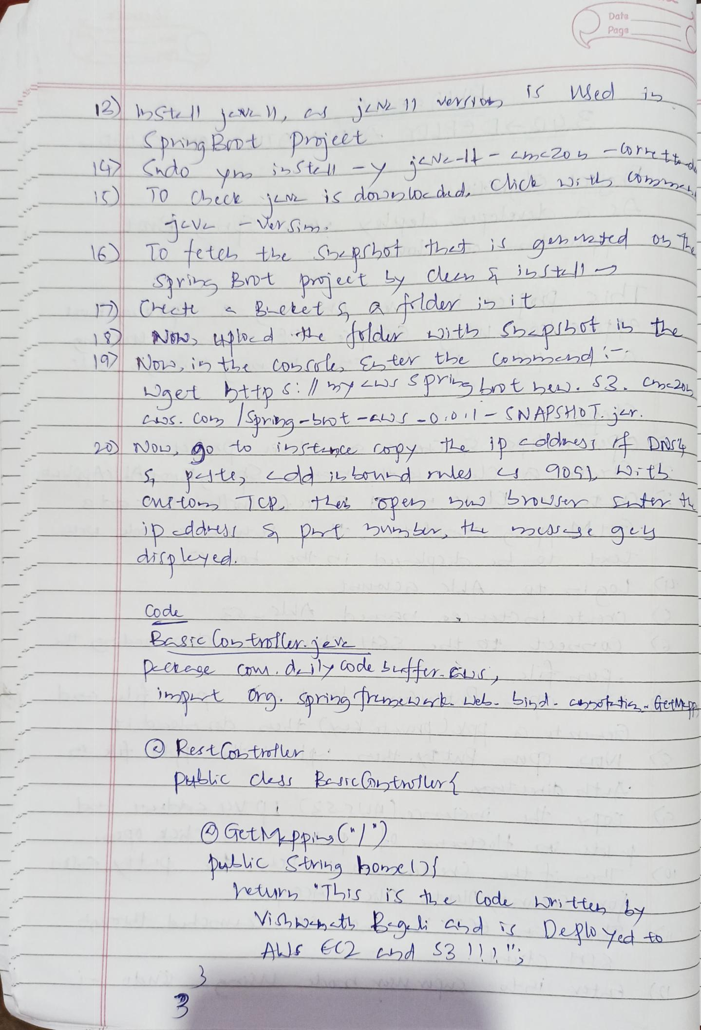
Data
Page

11 _{veitt} WedWedi5
¹ _{),} csj

¹² hdo |  | y | St =Y | Cho ^{E}
1O | 0 | (beck | domloedud. | Cho ^{E}
1O |  | (beck | c

he

ViY Sm
16 To etetLe
_{SY} Bro-t pet Ly Cu 5 ^{i} ¹²
BLetet a duy ^{it}
₂ N, _{ulo} d dldu L)th ^{bp!Lt iL}
- _{,intLt} Col, Ster the Cohoesnd

_{LAOS. Coy} /Hrhg-bot -L) -00 S ^{NAPSHD1ir}

o,
S e , Ldd ubnd wles ODS t

ip ddL S A w, t
ditg leyed.

Cod
Peste lDtlluxeV
e - ge Cow dily ode bLefr cC.

KestCotrfu
Publc cuAs PeJrc(aytnslur

GutMPpisC
^{etury his} iS A Cod
^{Vi} ht Bi Cd i
AJE C2_d S3 )

ntu, by
Deplo yed to

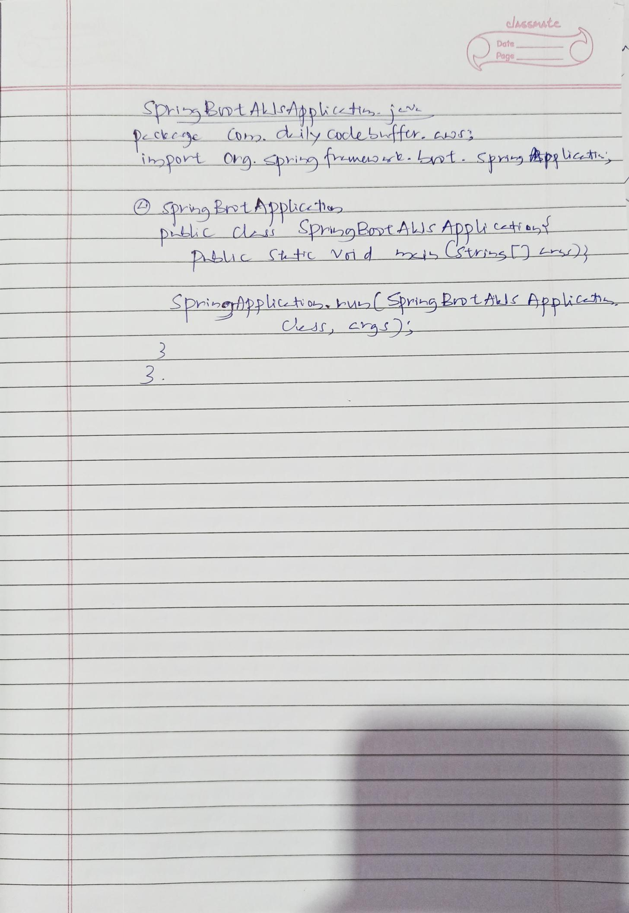
alAsSMAte

Date
Page

SphiBintALlsAdplkcotn
pckc CDo diy Cocle bfr . cos
ipo Ovg pi mue . pf . Sp9Bpg cAs

SprinsEniApplcha.
picCe SpngRt ALJ Appli cesiau

PALLc Stc Vid i Stins Lrs)

SprizeAppkto auaSpri-g PnLALLE APplich

C C

3

